# Busselton Senior High School



### Semester One Examination, 2017

### Question/Answer booklet

# MATHEMATICS

**METHODS**

**UNIT 3**

## Section One:

## Calculator-free

Your name

## Time allowed for this section

Reading time before commencing work: five minutes

Working time: fifty minutes

## Materials required/recommended for this section

***To be provided by the supervisor***

This Question/Answer booklet

Formula sheet

***To be provided by the candidate***

Standard items: pens (blue/black preferred), pencils (including coloured), sharpener, correction fluid/tape, eraser, ruler, highlighters

Special items: nil

## Important note to candidates

No other items may be taken into the examination room. It is **your** responsibility to ensure that you do not have any unauthorised material. If you have any unauthorised material with you, hand it to the supervisor **before** reading any further.

## Structure of this paper

|  |  |  |  |  |  |
| --- | --- | --- | --- | --- | --- |
| Section | Number of questions available | Number of questions to be answered | Working  time (minutes) | Marks available | Percentage of examination |
| Section One:  Calculator-free | 8 | 8 | 50 | 52 | 35 |
| Section Two:  Calculator-assumed | 11 | 11 | 100 | 98 | 65 |
|  | | |  | **Total** | 100 |

## Instructions to candidates

1. The rules for the conduct of examinations are detailed in the school handbook. Sitting this examination implies that you agree to abide by these rules.

2. Write your answers in this Question/Answer booklet.

3. You must be careful to confine your response to the specific question asked and to follow any instructions that are specified to a particular question.

4. Additional working space pages at the end of this Question/Answer booklet are for planning or continuing an answer. If you use these pages, indicate at the original answer, the page number it is planned/continued on and write the question number being planned/continued on the additional working space page.

5. Show all your working clearly. Your working should be in sufficient detail to allow your answers to be checked readily and for marks to be awarded for reasoning. Incorrect answers given without supporting reasoning cannot be allocated any marks. For any question or part question worth more than two marks, valid working or justification is required to receive full marks. If you repeat any question, ensure that you cancel the answer you do not wish to have marked.

6. It is recommended that you do not use pencil, except in diagrams.

7. The Formula sheet is not to be handed in with your Question/Answer booklet.

Section One: Calculator-free 35% (52 Marks)

This section has**eight (****8)** questions. Answer **all** questions. Write your answers in the spaces provided.

Working time: 50 minutes.

Question 1 (5 marks)

The graph below shows the curve $y=$ $\frac{180}{{\left(2x+5\right)}^{2}}$ and the line $x=5$.

Determine the area of the shaded region, enclosed by the $x-$ axis, the $y-$ axis, the line $x=5$ and the curve.

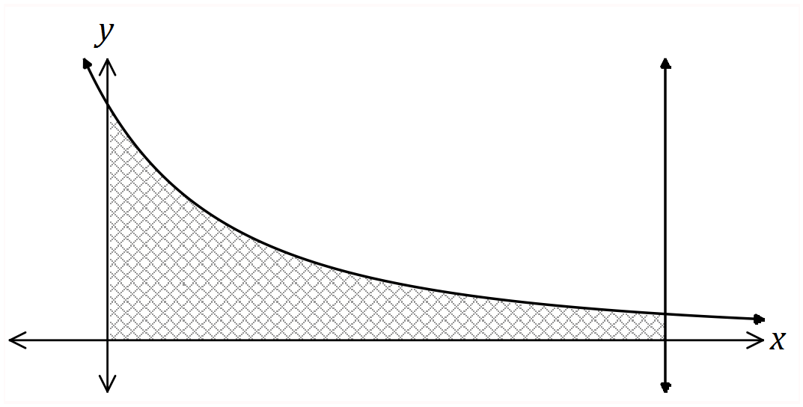

Question 2 (8 marks)

A small body, initially at the origin, moves in a straight line with acceleration ms-2, where is the time in seconds, $t≥0$. When $t=5$, it was observed to have a velocity of 31 ms-1.

(a) Determine an expression for $v(t)$, the velocity of the body. (2 marks)

(b) Determine the acceleration of the body when $v=19$. (3 marks)

(c) Determine the velocity of the body as it passes through the origin for the last time.

(3 marks)

Question 3 (6 marks)

The graph of $y=f(x)$ is shown below, where $f\left(x\right)=e^{x}(x^{2}-3)$.

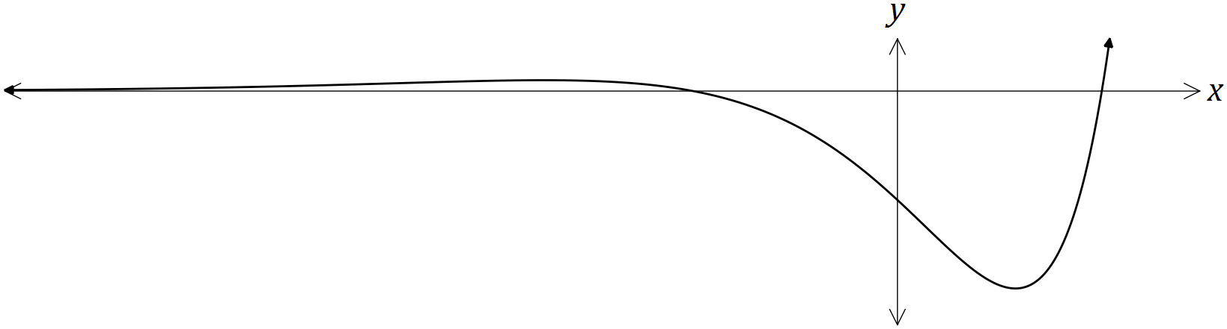

(a) Show that $f^{'}\left(x\right)=e^{x}(x^{2}+2x-3)$. (1 mark)

(b) Determine the $x-$ coordinates of the stationary points of $f(x)$. (2 marks)

(c) Given that $f^{''}\left(x\right)=e^{x}(x^{2}+4x-1)$, use the second derivative to justify that one of the stationary points is a local minimum and that the other is a local maximum. (3 marks)

Question 4 (8 marks)

(a) Determine $\frac{d}{dx}\left(\frac{1+e^{2x}}{1+\sqrt{x}}\right)$. (3 marks)

(b) Determine $\frac{d}{dx}$ $\left(2x\sin\left(3x\right)\right)$. (2 marks)

(c) Use your answer from (b) to determine $\int{6x\cos{(3x)}}dx$. (3 marks)

Question 5 (6 marks)

The table below shows the probability distribution for a random variable $X$.

It is known that $E\left(X\right)=1.7$ and $Var\left(X\right)=1.41$.

|  |  |  |  |  |
| --- | --- | --- | --- | --- |
| $$x$$ | $$0$$ | $$1$$ | $$2$$ | $$3$$ |
| $$P(X=x)$$ | $$a$$ | $$a+b$$ | $$b$$ | $$2a$$ |

(a) Determine the values of the constants $a$ and $b$. (4 marks)

(b) Determine

(i) $E(3-2X)$. (1 mark)

(ii) $Var(3-2X)$. (1 mark)

Question 6 (7 marks)

(a) The function $f$ is such that $f\left(1\right)=-2$ and $f^{'}\left(x\right)=\sqrt{3+x^{2}}$. Use the increments formula to determine an approximate value for $f(1.05)$. (3 marks)

(b) The function $C$ is such that $C\left(1\right)=10$ and $C^{'}\left(x\right)=3\sqrt{x+3}$.

(i) Explain why the increments formula would not yield an approximate value for $C(6)$.

(1 mark)

(ii) Determine $C(6)$. (3 marks)

Question 7 (6 marks)

A rectangle has its base on the $x-$ axis, its lower left corner at $(0, 0)$ and its upper right corner on the curve shown below, $y=\cos{2x}$, $0≤x≤\frac{π}{4}$.

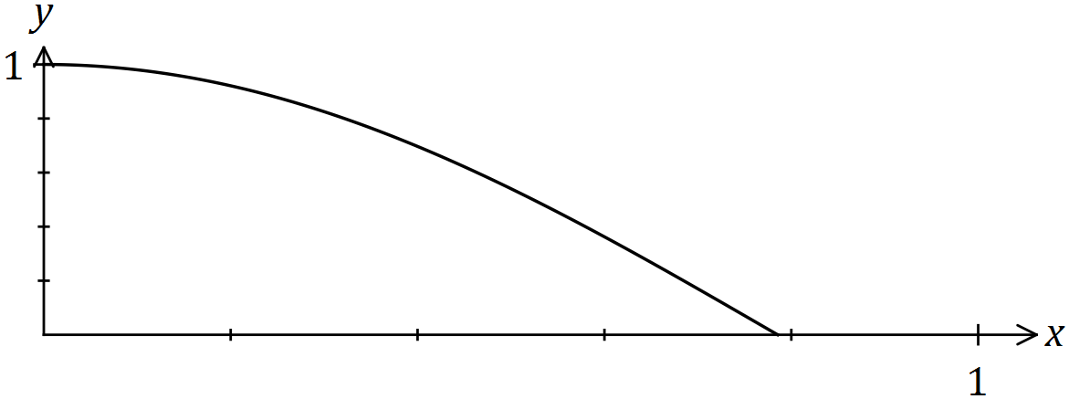

(a) Sketch a possible rectangle on the graph above and explain why the perimeter of the rectangle is given by the function $p\left(x\right)=2x+2\cos{2x}$. (2 marks)

(b) Determine the largest perimeter of the rectangle. (4 marks)

Question 8 (6 marks)

The graph of $y=f(t)$ is shown below over the interval $0≤t≤10$.

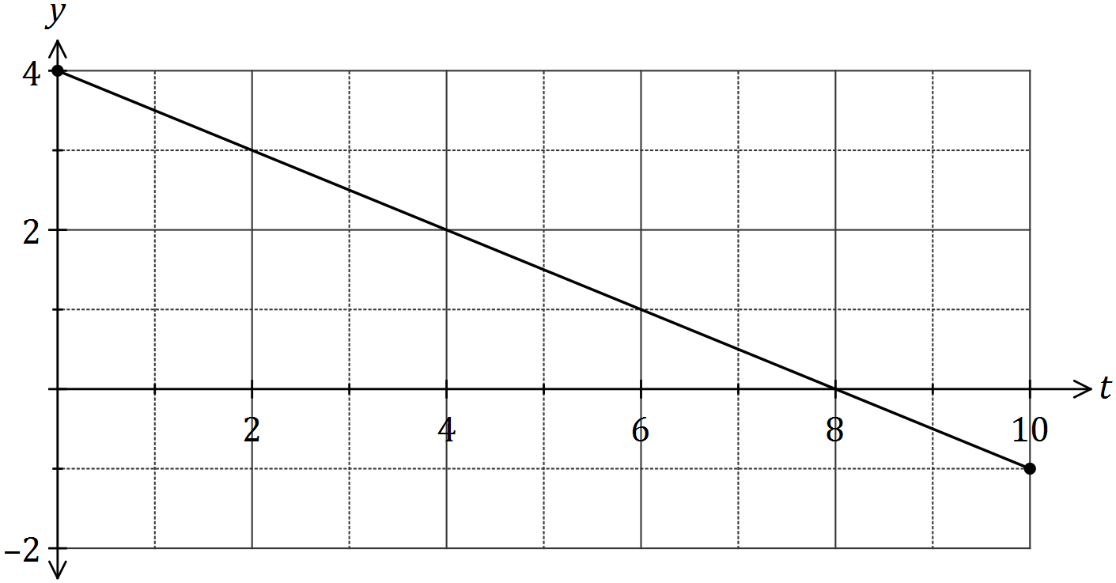

(a) Use the graph to determine an estimate for $\int_{0}^{2}{f(t)}dt$. (2 marks)

(b) On the axes below, sketch the graph of $y=F(x)$ for $0≤x≤10$, where $F\left(x\right)=\int_{0}^{x}{f(t)}dt$.

(4 marks)

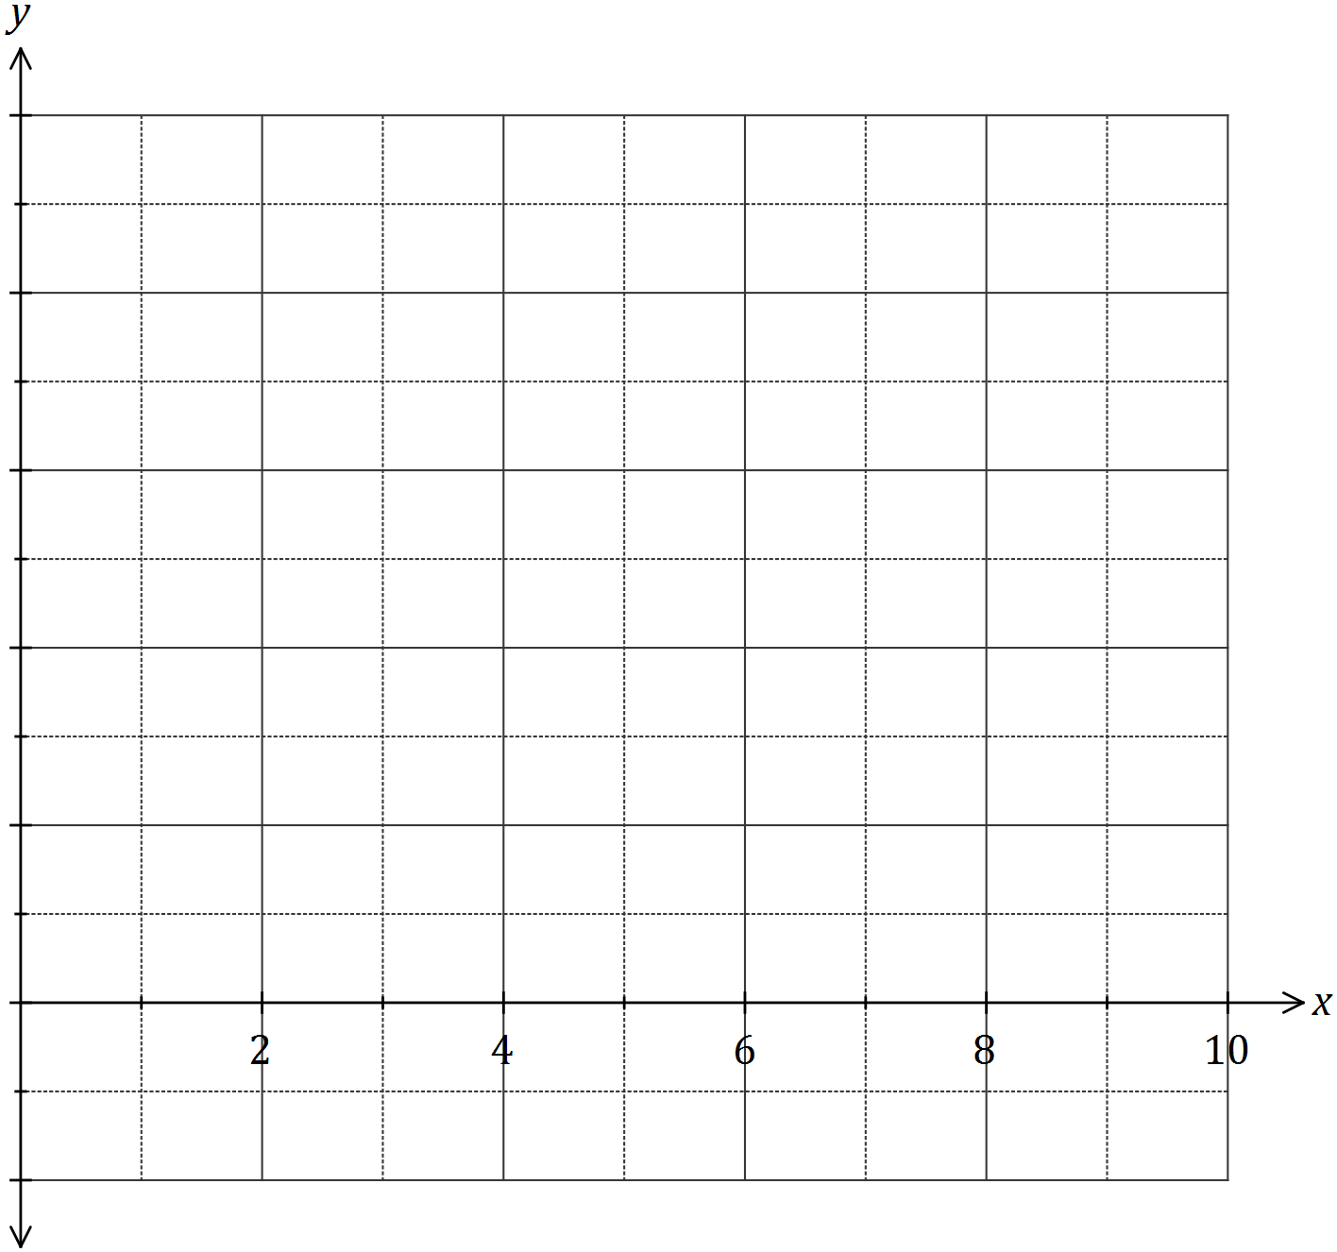

Additional working space

Question number: _________

© 2016 WA Exam Papers. Busselton Senior High School has a non-exclusive licence to copy and communicate this paper for non-commercial, educational use within the school. No other copying, communication or use is permitted without the express written permission of WA Exam Papers. SN177-095-1.